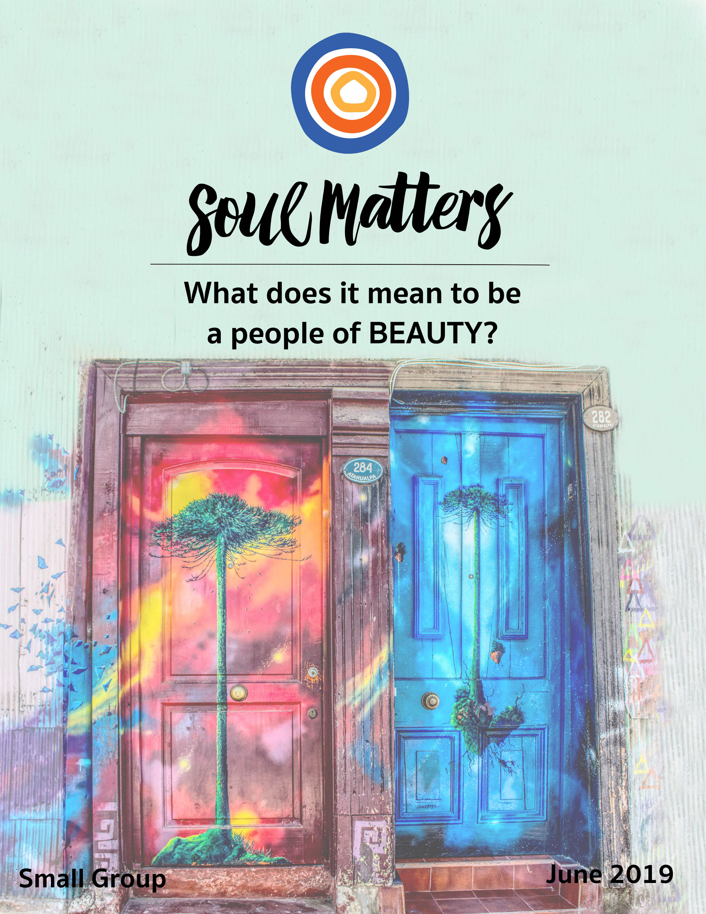

What Does It Mean To Be
A People of Beauty?

Where do you look for beauty?

There is universal agreement that we all must make time to visit museums and sit before stunning sunsets. But seeking beauty there is not enough. Every religion agrees: The secret to encountering spiritual beauty is to visit and observe the unlikely places. Indeed, one could argue that this is the job of religion. It exists to teach us and to help us observe beauty in the less noticed places. Just think of all the seemingly odd advice that religion sends our way:

“Notice your feet!”

There’s a beloved poem by Chilean poet Pablo Neruda about a pair of his socks. In this and other poems, he brings the ordinary things around us to life, helping us see how they so clearly carry the memories and meanings of our lives. Religion does the same. It tells us that these ordinary objects are not just background but beautiful partners. They don’t just enhance our relationship with the world and each other; they are among the most important relationships we have. They are fellow journeyers in and of themselves.

“Notice what’s at the front of the protest march!”

UU minister Sean Parker Dennison writes, “The ability to see beauty is the beginning of our moral sensibility. What we believe is beautiful we will not wantonly destroy.” With this we are reminded that beauty does more than soothe and heal. It demands. It calls. It creates commitment. It doesn’t just say “Love and appreciate me.” It says “Protect me! Fight for me!” It’s steps out in front of us and points to a precious world that needs our help. It paints a picture of new ways of living and declares, “Follow me there!” It’s not just the thing that nurtures our activist efforts. It is the reason we take to the streets.

“Notice yourself!”

Again beautiful things are not just objects to be appreciated and adored. They are not pretty things we purchase and possess. They possess us. They are containers for pieces and parts of ourselves. We don’t just observe them; we pour ourselves into them. They don’t just sit there; they open themselves up and invite us to spill our longings, memories, hopes and hurts into their care. When we observe them, we observe and re-member ourselves.

“Notice what’s behind it all!”

Our own Ralph Waldo Emerson writes, “The world is not painted or adorned, but is from the beginning beautiful; and God has not made some beautiful things, but Beauty is the creator of the universe.” The Quaker theologian Rufus Jones writes, “Beauty has no function, no utility… It greases no wheels, it bakes no puddings. It is a gift of sheer grace, a gratuitous largesse. It must imply behind things a Spirit that enjoys beauty for its own sake and that floods the world everywhere with it… Our joy in it shows that we are in some sense kindred to the giver and revealer of it.”

Here we are reminded that beauty is not just an elegantly painted portrait. It is also the artistic force of the universe that is constantly painting us. Pulling out the elegance in each of us and the world around us to create the portrait that is life.

So, yes, friends, by all means, get yourselves to the museum this month. Make time to gaze at the color-laced sky on your evening walks in the woods. But let’s not forget to also visit the unlikely places and the beauty that awaits us there.

Our Spiritual Exercises

Option A:

The Beautiful Thing You Carry

The philosopher Blaise Pascal wrote, “In difficult times, carry something beautiful in your heart.”

These are indeed difficult times. They require courage, commitment, hope and self-love. And all of them are sustained by beauty. We find the courage to fight after falling in love with a beautiful vision to fight for. We maintain our commitment only by finding the beauty that nourishes us. We hold on to hope because experiences of beauty remind us that something in the universe is on our side. We withstand dehumanization when rooted deeply in the beauty of our own dignity.

It’s one of the most important secrets to successful social change and social survival: When we carry beauty, it carries us.

So this month you are invited to get clear about the beautiful thing you need to carry. Or are carrying. Whether that be in your heart, head or literal pocket. Take some time to think about the source of beauty that sustains you. And then pick one action that will help you carry it with you in a more consistent way.

Option B:

The Beautiful Thing You Protect

Rev. Sean Parker Dennison writes, “The ability to see beauty is the beginning of our moral sensibility. What we believe is beautiful we will not wantonly destroy.”

Rev. Mary Katherine Morn writes, “Beauty does more than awaken us. It also admonishes us. It demands something… We are here so that together we might heed the admonitions of beauty. Answer its call to create, protect, and preserve.”

Reverends Morn and Parker Dennison remind us that beauty is more a salve. It does more than restore and sooth. It creates commitment. It lures us into loving it and becomes something we can’t live without. We end up willing to give our lives for it. We protect it at all costs.

So, what is that beautiful thing you protect at all costs? That core beautiful thing you defend like a mama bear because you know you’d be lost without it? For some of us, it’s a form of nature. For others, it’s a type of justice. For still others, it’s a way of treating each other, like kindness. Or treating ourselves, like self-love. Whatever it is, we all build our lives around it. Look closely and you’ll notice how deeply it defines us. By protecting it, we protect ourselves.

Spend some time this month getting clear about that piece of beauty that turns you into a mama bear. After all, isn’t getting clear about it is what life is all about?

Option C:

Enter the World of Ordinary Beauty

We’ve all had those moments. The ordinary suddenly appears extraordinary. One minute the objects around us blend into the background, sit there as “things.” The next they come to life, so clearly carrying meaning and memory. What once seemed possessions, now somehow possess us. They are a part of us. And us them. All it takes is a different kind of attention for their appearance to change. When it happens, it’s beautiful.

This month make some time to lean into this sacred form of attention and re-enter this world of ordinary beauty. Start by exploring the poets and poems listed below. Consider them guides. Helping you navigate your way into this beautiful and precious space of noticing in a deeper way.

Respond to the pieces in any way that feels natural. Maybe you’ll write an ode of your own. Maybe you’ll spend a little more time touching, smelling or sitting with the lovely things that surround you. Maybe you’ll pull one of those lovely things out of the pile it’s been lost in and put it in a place you pass by each day.

Whatever it is, come to your group ready to share which of the poems below affected you the most and how it led you to respond.

Ode to Things - Pablo Neruda: https://www.youtube.com/watch?v=tz82ikSllKo
Ode to My Socks - Pablo Neruda: https://www.youtube.com/watch?v=1GOkypeafdM
Ode to the Watermelon - Pablo Neruda: https://www.youtube.com/watch?v=LRTXVYGqT_k
Burial & To the Fig Tree on 9th & Christian - Ross Gay: https://www.youtube.com/watch?time_continue=300&v=YRjEgOoFI68
To the Mulberry Tree - Ross Gay: https://www.youtube.com/watch?time_continue=14&v=jzLx2aRNTRU
Ode to the Women on Long Island - Olivia Gatwood: https://www.youtube.com/watch?v=kqpip0H1QTE
Ode to Thrift Stores - Ariana Brown: https://www.youtube.com/watch?v=PFZJoU44uOo
A Personal Reflection on Neruda and “our things”: https://www.youtube.com/watch?v=SRiCUqi-4Y4

Option D:

Remind Yourself that You are Pretty ______!

“Will I be pretty?” It’s more than a song whose tune is stuck in our heads. For so many of us, it’s a burden stuck in our skin. A big part of being a people of beauty is wrestling with the way culture’s conceptions of beauty have distorted and disrupted our relationship with our bodies and souls.

Poet Katie Makkai takes this head on in her poem Pretty. In it, she unfolds the challenge of reclaiming and transforming the call to be “pretty.”

You are invited this month to turn her call into a spiritual exercise by completing one (or maybe all) of these sentences:

“I am most proud of the fact that I am pretty ____________.”
“I hope my child knows they are pretty ____________.”
“I love my partner because they are pretty _____________.”
“I never knew I was pretty _____________ until ____________ helped me realize it.”
“The moment I realized I could be pretty ____________ was when I ____________.”
“I still want to become pretty ______________.”

Your work will become clear after you watch the video:
https://www.youtube.com/watch?v=f7TS2Z6lAI4

Option E:

Find Beauty in Our Recommended Resources

Our recommended resources are full of wisdom about what it means to be a people of and a person of beauty. Engaging these resources and finding the one that especially speaks to you is a spiritual practice in and of itself.

So, if none of the above exercises call to you, engage the recommended resources section of this packet as your spiritual exercise for the month.

Set aside some regular time throughout a week to go through them and meditate on them until you find the one that most expands or deepens your understanding of sanctuary. After you’ve found it, consider printing it out and carrying it with you or pinning it up so you can continue to reflect on it throughout the weeks leading up to your group meeting. Come to your group ready to share where the journey led you.

Your Question

As always, don’t treat these questions like “homework” or try to answer every single one. Instead, make time to meditate and reflect on the list and then pick the one question that speaks to you most. The goal is to figure out which question is “yours.” Which question captures the call of your inner voice? Which one contains “your work”? What is it trying to get you to notice?
(Sometimes it helps to read the list to a friend or loved one and ask them which one they think is the question you need to wrestle with!)

- When were you first healed by beauty?
- When were you first protected by beauty?
- When did beauty first teach you something?
- When was beauty a doorway to the divine?
- What makes a beautiful soul? What do you do to beautify your own soul?
- What’s the most beautiful thing you’ve ever seen?
- What did your family of origin teach you about what it means “to be beautiful”?
- What parts of life have grown more beautiful as you’ve aged?
- What’s something you know now about beauty that you didn’t know when you were 16 years old?
- Is beauty a private thing for you? Or do you need to share it with someone for the experience to be complete?
- What if beauty isn’t something we encounter but something we become?
- Who in your life needs told they are a beautiful soul?
- Have you ever experienced a “beautiful goodbye”?
- What’s your question? Your question may not be listed above. As always, if the above questions don't include what life is asking from you, spend the month listening to your days to hear it. Or maybe the question or call you need to hear is waiting in one of the quotes listed below. Consider looking there!

Companion Pieces

Recommended Resources for Personal Exploration & Reflection

The following resources are not required reading. We will not analyze these pieces in our group. Instead they are here to companion you on your journey this month, get your thinking started and open you to new ways of thinking about what it means to be part of a people of BEAUTY.

Word Roots

The Greek word for the beautiful is kalon, “which is related to the word kalein, which includes the notion of ‘call.’ Suggesting that there is something about beauty, wherever we find it, that tugs at us, pulls at us, drawing us into the divine.”

A second Greek word for beauty is hōraios, from hōra, meaning "hour." Beauty was thus associated with "being of one's hour". Thus, a ripe fruit (of its time) was considered beautiful, whereas a young person trying to appear older or an older person trying to appear younger would not be considered beautiful.

The Ancient Greeks also equated beauty with harmony and virtue, which brings together the ideas of “call” and “hour.” Beauty is not a static experience but one of being in the rightness of the moment, an expression of the divine.

Wise Words

Beauty, as a philosophical concept, is rather mysterious — a slippery elf, hard to catch hold of, impossible to define. But let me try anyway: Beauty is that which glistens on the edges of our yearnings and lures us into the depths of things.
Patricia Adams Farmer

Beauty isn’t all about just nice loveliness, like. Beauty is about more rounded, substantial becoming. So I think beauty, in that sense, is about an emerging fullness.
John O’Donohue

We can argue about the reason for the universe and the meaning of the universe but not about the beauty of the universe… We all share beauty. It strikes us indiscriminately. It may be when our child was born into this world; or a simple flower; or a song; or a smile on a face; or a great act of courage; or a dance well done; or a child’s laugh; or a loaf of bread baking; or finding a worthy job; or a snowfall; or when drawn to the Source of Life itself. There is no end to beauty for the person who is aware.
Matthew Fox paraphrasing Ernesto Cardenal

Beauty is the object of longing. We're accustomed to thinking that it is the beautiful thing that causes desire to erupt in us, but perhaps that is not always, or even usually, the case. First, we long. We may not even be conscious of our longing, but because we long, what we long for eventually finds an object in the world, and upon that thing our hearts and imaginations become fixed.
Crispin Sartwell

At some point in life the world’s beauty becomes enough. You don’t need to photograph, paint or even remember it. It is enough. No record of it needs to be kept and you don’t need someone to share it with or tell it to.
Toni Morrison in Tar Baby

In each moment, expect a miracle: ten kinds of birds at the feeder, and the tracks of a fox in the snow.
Pick up a magnifying glass and scrutinize that crocus… Be astonished at the flower, arrested by its beauty. Run naked through the garden early in the morning and hope the wild geese fly by.
Elizabeth Tarbox

We must first allow ourselves to be captured by the goodness, truth, or beauty of something beyond and outside ourselves. Then we universalize from that moment to the goodness, truth, and beauty of the rest of reality, until our realization eventually ricochets back to include ourselves!
Richard Rohr

Beauty has no function, no utility… It greases no wheels, it bakes no puddings. It is a gift of sheer grace, a gratuitous largesse. It must imply behind things a Spirit that enjoys beauty for its own sake and that floods the world everywhere with it… Our joy in it shows that we are in some sense kindred to the giver and revealer of it.
Rufus Jones

Monet Refuses the Operation
Lisel Mueller
Full poem found at https://www.poetryfoundation.org/poems/52577/monet-refuses-the-operation-56d231289e6db

I tell you it has taken me all my life
to arrive at the vision of gas lamps as angels...
to learn that the line I called the horizon
does not exist and sky and water,
so long apart, are the same state of being...
if only you could see
how heaven pulls earth into its arms...

This a wonderful day. I've never seen this one before.
Maya Angelou

One Talent
Rev. Steve Garnaas-Holmes

Sunrise and its gold,
a single kiss,

the sea that never tires
throwing its beauty at you,

trees scattering jewels,
stars saying their prayers

by candlelight
in their little houses—

such loveliness,
such precious coins.
You can't say what they're worth,
there is no measuring them

any more than the one you are,
little star among millions,

generous, infinite Talent
unburied,

mere single radiant
sun.

The secret of ugliness consists not in irregularity, but in being uninteresting.
Ralph Waldo Emerson

Beauty always has rules. It’s a game. I resent the beauty game when I see it controlled by people who grab fortunes from it and don’t care who they hurt. I hate it when I see it making people so self-dissatisfied that they starve and deform and poison themselves.
Ursula K. Le Guin

If only our eyes saw souls instead of bodies how very different our ideals of beauty would be.
anonymous

One of the huge confusions in our times is to mistake glamour for beauty.
John O’Donohue

It’s the question of beauty… there are individuals holding out on frontlines, holding the humane tissue alive in areas of ultimate barbarity, where things are visible that the human eye should never see. And they’re able to sustain it, because there is, in them, some kind of sense of beauty that knows the horizon that we are really called to in some way. I love Pascal’s phrase, that you should always keep something beautiful in your mind. And I have often — like in times when it’s been really difficult for me, if you can keep some kind of little contour that you can glimpse sideways at, now and again, you can endure great bleakness.
John O’Donohue

Human beings have a hard time regarding anything beautiful without wanting to devour it.
Barbara Brown Taylor

That which is striking and beautiful is not always good, but that which is good is always beautiful.
Ninon de L’Enclos

The beauty of the world is the mouth of a labyrinth… if [we do] not lose courage, if [we go] on walking, it is absolutely certain that [we] will finally arrive at the center of the labyrinth. And there God is waiting…
Simone Weil

Beauty disciplines our hearts to joy like riverbanks nudging the current ever closer to the sea.
Priscilla Stuckey

There are three ways in the world: dangerous, wounding, and beauty.
Linda Hogan

There is nothing more beautiful than someone who goes out of their way to make life beautiful for others.
Mandy Hale

The ability to see beauty is the beginning of our moral sensibility. What we believe is beautiful we will not wantonly destroy.
Rev. Sean Parker Dennison

Beauty does more than awaken us. It also admonishes us. It demands something… We are here, in religious community, not to hide from the anguished cries or the tender lullabies. We are here, in religious community, not to protect our hearts from breaking. We are here together to borrow courage for the task of coming alive. We are here so that together we might heed the admonitions of beauty. Answer its call to create, protect, and preserve.
Rev. Mary Katherine Morn

In such ugly times, the only true protest is beauty.
Phil Ochs

In difficult times, carry something beautiful in your heart.
Blaise Pascal
How
Did the rose
Ever open its heart
And give to this world
All its
Beauty?
It felt the encouragement of light
Against its
Being,
Otherwise,
We all remain
Too
Frightened.

Hafiz

To make injustice the only
measure of our attention is to praise the Devil.
If the locomotive of the Lord runs us down,
we should give thanks that the end had magnitude.
We must admit there will be music despite everything...
To hear the faint sound of oars in the silence as a rowboat
comes slowly out and then goes back is truly worth
all the years of sorrow that are to come.
Jack Gilbert

For the world is not painted or adorned, but is from the beginning beautiful; and God has not made some beautiful things, but Beauty is the creator of the universe.
Ralph Waldo Emerson

In my youth I am aware of it
and in my old age I shall walk quietly
the beautiful trail.
In beauty it is begun
and in beauty it is ended.
Navajo Blessing

Spend all you have for loveliness,
Buy it and never count the cost…
Sara Teasdale

Songs and Music

Beauty In The World
Macy Gray
https://www.youtube.com/watch?v=0qX7ZsxD3Ik
A beautiful cover! https://www.youtube.com/watch?v=a0lKM-9Olks

Beautiful World
Colin Hay
https://www.youtube.com/watch?v=xe3RqgnXaT4

Scars To Your Beautiful
Alessia Cara

https://www.youtube.com/watch?v=cUJttxsxIDU
Grace VanderWaal cover: https://www.youtube.com/watch?v=ywu6ZQn1Yas
Dance response: https://www.youtube.com/watch?v=cUJttxsxIDU

The Way I Am
Ingrid Michaelson
On the beauty of being loved...
https://www.youtube.com/watch?v=UykS82dpGrE

Not A Pretty Girl
Ani Difranco
https://www.youtube.com/watch?time_continue=64&v=-XxxfRBLW0o (with video meditation)
Live: https://www.youtube.com/watch?time_continue=77&v=KqEFR6dpq_A

More “Beauty Songs” are found on our June Soul Matters Spotify playlist. Click here to check them out! You can also explore the playlists from other months here.

Videos & Online

The Inner Landscape of Beauty - John O’Donohue: On Being Podcast
https://onbeing.org/programs/john-odonohue-the-inner-landscape-of-beauty-aug2017/
“No conversation we've ever done has been more beloved than this one. The Irish poet, theologian, and philosopher insisted on beauty as a human calling…”

There is Beauty in Not Knowing - video and spoken meditation
Richard Feynman
http://www.karmatube.org/videos.php?id=2688
Explores beauty through the eyes of physicist Richard Feynman: emotional, visually beautiful, intellectually evocative.

How Beauty Can Heal Us
Shots of Awe / Jason Silva
https://www.youtube.com/watch?v=2W6wJniitTU
A meditation on the soul-shaking, heart-stirring power of beauty. You become what you behold. So choose carefully what you behold. Chase beauty friends, so you become it.

Body Positivity or Body Obsession? - TED Talk
https://www.youtube.com/watch?v=uDowwh0EU4w
“Women are suffering because they are seen as bodies first and people second. So rather than working to make sure more women’s bodies are viewed as valuable, we are focused on making sure that women are valued as more than bodies to view...

The Body Is Not An Apology
Sonya Renee Taylor
https://www.youtube.com/watch?list=PLcT5qi3lZBNzMhaUllqjrUXKflByJNYZM&time_continue=75&v=B7lKPdh_y-8
Lean into the blessing, beauty and divinity of your body…

Pretty
Katie Makkai
https://www.youtube.com/watch?v=f7TS2Z6lAI4

Beautiful Body
Natalie Patterson
https://www.youtube.com/watch?v=IealjFA1l8o

Youth React to Being Called Beautiful
https://www.youtube.com/watch?v=aW8BDgLpZkI

The World Reacts To Being Called Beautiful
https://www.youtube.com/watch?v=kAPdf51MS2I

The Joy, Grief and Beauty of Caring for an Aging Parent - TED Talk
https://www.ted.com/talks/tony_luciani_a_mother_and_son_s_photographic_journey_through_dementia?utm_source=newsletter_weekly_2019-01-19&utm_campaign=newsletter_weekly&utm_medium=email&utm_content=talk_of_the_week_image#t-469396

City Vérité
“A video series that illuminates the life and beauty of various world cities by capturing the breathtaking, intimate, and eye-catching moments from a single day in that city’s life.” We recommend starting with these two:
Gaza City: https://vimeo.com/131154055
New York City: https://vimeo.com/124534647

Beauty Interpreted - Picasso’s Guernica, Explained to Passersby in a NYC Subway
https://www.vulture.com/2018/12/picassos-guernica-explained-to-passersby-in-a-nyc-subway.html

52 Frames - Photography Challenge Site
Let these photographers help you experience the beauty around you through a new lens…
The Sky: https://www.facebook.com/pg/52frames/photos/?tab=album&album_id=2077360855622357
Common Objects: https://www.facebook.com/pg/52frames/photos/?tab=album&album_id=2055675487790894
Religion: https://www.facebook.com/pg/52frames/photos/?tab=album&album_id=1539303049428143
Hands: https://www.facebook.com/pg/52frames/photos/?tab=album&album_id=1322136651144785
Magic Hour: https://www.facebook.com/pg/52frames/photos/?tab=album&album_id=1179922898699495
Street Artist JR Ends Mexico Border Installation with Picnic on Both Sides
https://mymodernmet.com/jr-street-art-us-mexico-border/?fbclid=IwAR0gF2KE_xmvjn4ic8EZHg18pki9uYWKzkYYtCmguh7oGXWEkj2ppxOT8Co

Articles

Nature’s Beauty as a Gateway into Deep Time and a Lens on the Interconnectedness of the Universe
Maria Popova
https://www.brainpickings.org/2018/07/17/oliver-sacks-beauty-deep-time/

“Standing amid the rainforest — a place governed by the beauty of interrelation — Sacks reflects: ‘The sense of deep time brings a deep peace with it, a detachment from the timescale, the urgencies, of daily life… a profound sense of being at home, a sort of companionship with the earth.’”

Wabi-Sabi: The Art and Beauty of Imperfection - Utne Reader
https://www.utne.com/mind-and-body/wabi-sabi

Ugly: How Beauty was Built upon White Supremacy
Vanessa Rochelle Lewis
https://wearyourvoicemag.com/body-politics/bopoincolor/ugly-white-supremacy-beauty
“In this essay for #BodyPositivityInColor, Vanessa Rochelle Lewis explores the concept of “ugly” and how it depends on white supremacist, colonialist, cisheteronormative, misogynistic, and ableist constructs of what defines beauty. She explores these ideas through history and how it exists and thrives within our current society.”

Books

Beauty: The Invisible Embrace
John O’Donohue
https://www.amazon.com/Beauty-Invisible-Embrace-John-ODonohue/dp/0060957263/ref=asc_df_0060957263/?tag=hyprod-20&linkCode=df0&hvadid=312281483245&hvpos=1o1&hvnetw=g&hvrand=9334313553809628817&hvpone=&hvptwo=&hvqmt=&hvdev=c&hvdvcmdl=&hvlocint=&hvlocphy=9005606&hvtargid=pla-435452636568&psc=1
“An enchanting meditation on how beauty lays its claim on the human spirit in such disparate realms as music, love, imperfection, death, and desire.” - Maria Popova

Old In Art School: A Memoir of Starting Over
Nell Irvin Painter
https://www.amazon.com/Old-Art-School-Memoir-Starting-ebook/dp/B0771HQPNX/ref=pd_sim_351_4?_encoding=UTF8&pd_rd_i=B0771HQPNX&pd_rd_r=bdb3678a-2ae1-11e9-9464-d972d800d7c3&pd_rd_w=5UUVB&pd_rd_wg=o44Mq&pf_rd_p=90485860-83e9-4fd9-b838-b28a9b7fda30&pf_rd_r=JMHTPPQQVEEMY4PF4GH8&psc=1&refRID=JMHTPPQQVEEMY4PF4GH8

"Painter claims her birthright as an artist, a black woman, and a woman of a certain age at a time and in a cultural milieu that ignores all three." ―CNN
"The book is beautifully written, fun and funny, describing how, after a life of overcoming unfair treatment as a black woman, she is now fighting the discrimination of being OLD, black, and female . . . Old in Art School appeals not just to those who dream about becoming late-in-life artists, but anyone who grapples with how to direct their energies post-retirement. In this sense, being an 'artist' is more about designing your life, defying the kind of giving up that retiring sometimes implies." ―Hyperallergic

Truth & Beauty: A Friendship
Ann Patchett
On the beauty of friendship.

Movies

Real Women Have Curves
https://www.rottentomatoes.com/m/real_women_have_curves
On the tangled web of beauty, culture and family relationships.

This Beautiful Fantastic
https://www.rottentomatoes.com/m/this_beautiful_fantastic_2017/

A Beautiful Mind
https://www.rottentomatoes.com/m/beautiful_mind
Definitely time to watch it again!

Get daily inspiration
on the monthly theme by liking our
Soul Matters Facebook inspiration Page:
https://www.facebook.com/soulmatterssharingcircle/

Find musical inspiration
on each theme by following our monthly
Spotify Lists:
https://www.soulmatterssharingcircle.com/spotify-lists.html

Find support for bringing the
monthly themes home and into your family life with
Soulful Home: A Guide for Families:
https://www.soulmatterssharingcircle.com/soulful-home.html

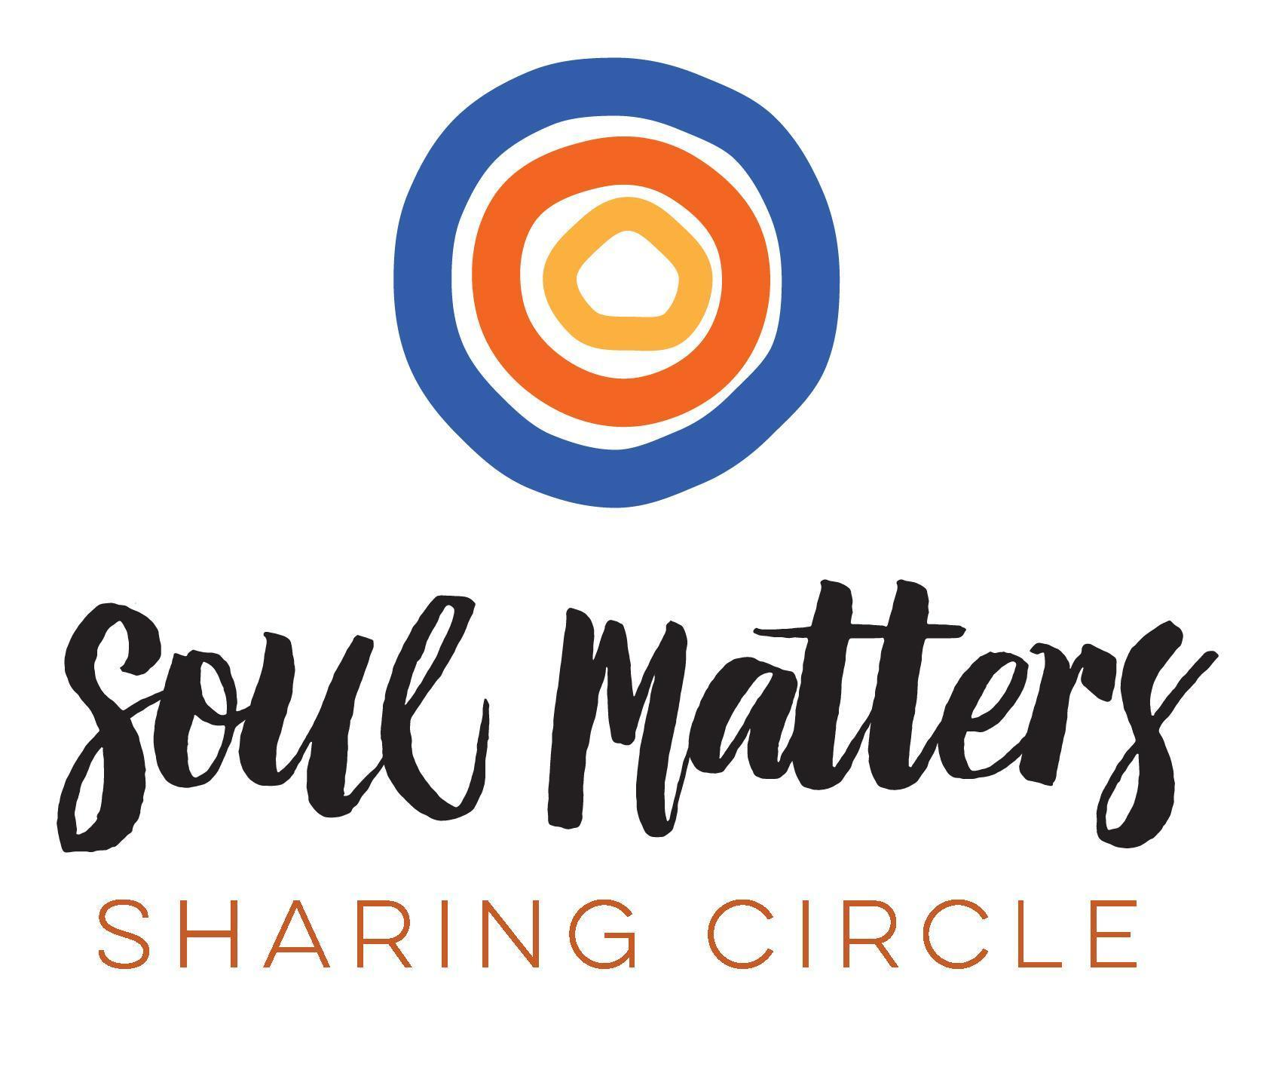
© 2018-19 Soul Matters ALL RIGHTS RESERVED

Packets are for use only by member congregations of the Soul Matters Sharing Circle.
Learn how to join athttp://www.soulmatterssharingcircle.com

